MCMC Assignment

Group: John Flynn, Jordan Menchen, Shelby Stocker

**Description:**

To begin this assignment, we split up the calculations for each probability table and proceeded to double check each calculation. We made sure to ensure accuracy in these calculations as our program would reference these values over thousands of iterations. We then moved to the actual development phase of the assignment where our group sat down and designed our program to run 5 separate runs of 10,000 instances each. The actual calculations involve calculating the ratio of the number of times that B=T to the number of iterations every 1,000 iterations. We then used the matplotlib library to track all of our data and present each run on a single graph in a way that is easily readable. Using that graph we were then able to look at how the data converged.

**Conditional Probability Tables:**

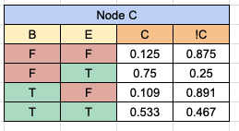

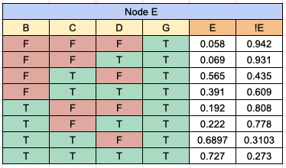

**Data and Graphs:**

**Observations/Patterns noticed:**

The graphs consistently have shown a convergence around the range of .09 - .1 for the vast majority of the runs conducted.

**What I Learned:**

To be completely honest the only stats class I took in my academic career I did not take tremendously seriously so this project really forced me to dig in and learn to respect what statistics has to offer to the greater scientific community. It was interesting to understand the significance of Monte Carlo Markov Chains and how to calculate conditional probabilities specifically.